HOME SLEEP TEST ORDER FORM
SWC HST appointment Date: _________________________ LPA Chart #: ________________________
Patient Name: _____________________________________ Date of Birth:________________________
Address: __________________________________________ Home Phone: ________________________
__________________________________________________ Cell: _______________________________
Email: _____________________________________________ Follow up: PCP or SWC
Epworth Sleepiness Score _____ Height: _____ Weight: _____ BMI: ________ M / F
ORDER Portable Sleep Study x 2 nights, Entire night diagnostic study, Unattended sleep study, CPT: 95806 x 2
SIGNS AND SYMPTOMS:
Witnessed Apnea (more than 2 events) Excessive Daytime Sleepiness Known or Suspected OSA
Snoring Difficulty breathing noted in sleep Atrial Fibrillation/Other arrhythmia
Change in weight + / - _______
Others reason/symptoms not listed above for HST: ________________________________________________________
Contraindications for HST: If any of these are present then patient should be referred for an in-lab attended study.
- Moderate to Severe COPD (FEV1 <70%)
- Poorly controlled asthma (especially if effecting sleep)
- Moderate to Severe CHF (ordinary activity produces fatigue)
- Oxygen dependent
- Presently using narcotics (any amount)
- Cognitive impairment
- Physical impairment (adjusting straps to proper tightness, cannula in place, etc)
- 18 year of age or younger
Less commonly seen but definite exclusions to Home Testing:
- Neuromuscular impairment - Recent h/o CVA (within 30 days)
- Seizure disorder not well controlled. - Previously Suboptimal HST (2 failed attempts)
- History of arrhythmias – VT/VF - Previous HST not showing OSA but ongoing symptoms
- Sleep disorders other than OSA:
Narcolepsy REM Behavior Disorder
Restless Leg Syndrome Central Sleep Apnea

___________________________/_______________ ___________________
Provider Signature / Date NPI
Provider Initials ___________

EPWORTH SLEEPINESS SCALE

How likely are you to doze off or fall asleep in the following situations, in contrast to feeling just tired? This refers to your usual way of life in recent times.

Use the following scale to choose the most appropriate number for each situation:
0 = would never doze
1 = slight chance of dozing
2 = moderate chance of dozing
3 = high chance of dozing
It is important that you answer each question as best you can.

Situational Chance of Dozing (0-3)

Sitting and reading _____

Watching _____

Sitting, inactive in a public place (e.g. a theatre or a meeting) _____

As a passenger in a car for an hour without a break _____

Lying down to rest in the afternoon when circumstances permit _____

Sitting and talking to someone _____

Sitting quietly after a lunch without alcohol _____

In a car, while stopped for a few minutes in the traffic _____

TOTAL _____

LPA Sleep Wellness Center:

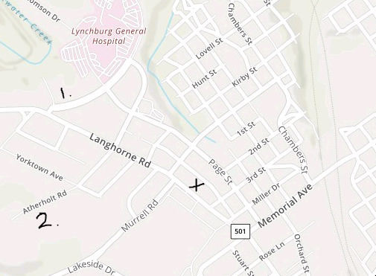

“X” Sleep Wellness Center, 2512 Langhorne Rd, 434-528-2194
“1” CVFP , Tate Springs Rd
“2” Centra Cardiology, Atherholt Rd

